Skyline Drift Time Predictor Training (DRAFT)

In this tutorial, you will learn how data from a simple mixture can be used to create drift time predictions for use with more complex samples. By first training on a simple data set, in this case BSA in water, drift time predictions can be developed that greatly improve Skyline’s ability to pick peaks for analytes of interest in a more complex mixture, by using Ion Mobility Separation to reduce peak interference.

It is assumed that you already have some familiarity with Skyline, so we skip over basic steps like importing a transition list and so forth. If you are not familiar with Skyline, you should first work through some of the introductory tutorials at <https://skyline.gs.washington.edu/labkey/wiki/home/software/Skyline/page.view?name=tutorials> .

# Getting Started

To start this tutorial, download the ZIP file at:

<https://skyline.gs.washington.edu/tutorials/TrainedDriftTimePredictionTutorial.zip>

Extract the files in it to a folder on your computer, like:

C:\Users\bspratt\Documents

This will create a new folder:

C:\Users\bspratt\Documents\TrainedDriftTimePredictionTutorial

This folder will contain the Skyline files necessary for this tutorial. In addition to these files, the mass spec data needs to be downloaded from the Chorus Project data repository at <https://chorusproject.org> (as of this writing, Chorus does not support chromatogram extraction on IMS data, so we have to make a local copy of the data).

If you don’t have a Chorus account, register for one now. Then go to <https://chorusproject.org/pages/dashboard.html#/experiments/shared/1962/files?page=1&items=25&sortingField=uploadDate&asc=false> [**NB this is not the ultimate link – we need to make this data public, this link probably only works for BrianP – and anyway, the files there are damaged – find a local copy if you can**]

And individually download the files:

BSA_Frag_100nM_18May15_Fir_15-04-02.d.zip (ID 98997)  
Yeast_0pt1ug_BSA_50nM_18May15_Fir_15-04-01.d.zip (ID 99021)

This is a total of nearly 5GB of data, so download may take a while. Once they are downloaded, unzip them to your previously created “Documents\TrainedDriftTimePredictionTutorial “ folder.

# Start Skyline and Open the Example Skyline Document

If you are not already running Skyline, start it now. Use the File | Open menu item to open the file “TrainedDriftTimePredictionTutorial.sky” in your newly created “Documents\TrainedDriftTimePredictionTutorial’ directory.

The document has no mass spec results loaded yet, and looks like this:

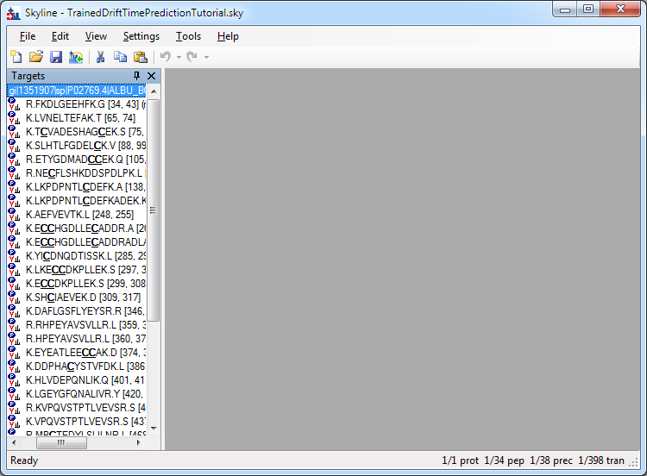

# Import the Results Data

We will import both the training data and the mixture data. Initially we just want to look at the mixture data to see how bad the interference is between the analytes of interest and everything else in the mix. We will load the training data at the same time just to save time, since Skyline can load it in parallel with the mixture data.

Selecting File | import | Results from the Skyline menu brings you here:

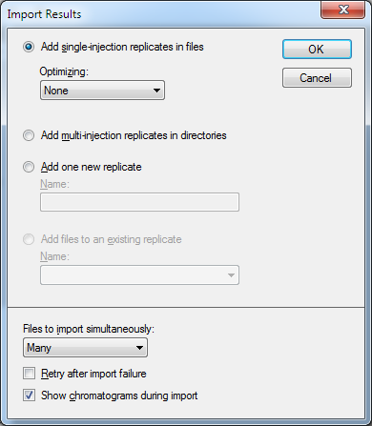

Make sure the “Files to import simultaneously” control is set to “Many” – this tells Skyline to import more than one file at a time, for best performance. Then click on the “OK” button.

From the next window, select the previously downloaded files "BSA_Frag_100nM_18May15_Fir_15-04-02.d" and "Yeast_0pt1ug_BSA_50nM_18May15_Fir_15-04-01.d".

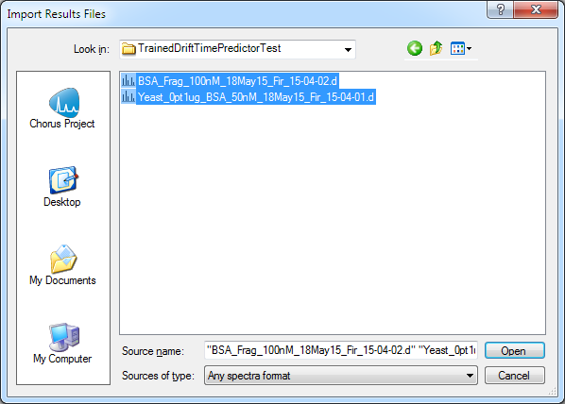

If you checked the “Show chromatograms during import” box, during import you will see a progress window like this:

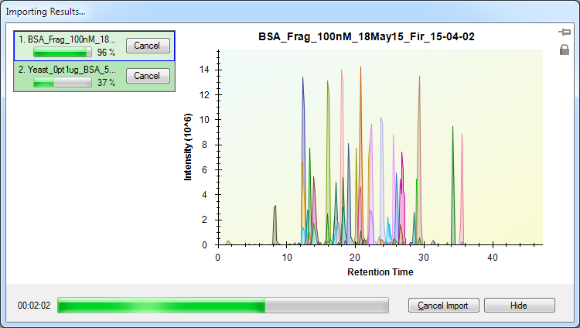

"BSA_Frag_100nM_18May15_Fir_15-04-02.d" contains the raw data from a tryptic digest of BSA in water, which should give a nice clean training set for BSA peptide drift times. "Yeast_0pt1ug_BSA_50nM_18May15_Fir_15-04-01.d" contains the raw data from a mixture of BSA and yeast. It’s easy to see that the mixture has a lot more peak interference.

Once the data is imported, we can examine the mixture alongside the simple data set and see how much peak interference there is. Use the View | Arrange Graphs | Tiled menu item to set up a side by side view, and then View | Auto Zoom | Best Peak for convenience, then click on the R. HPEYAVSVLLR.L peptide to see an example if interference:

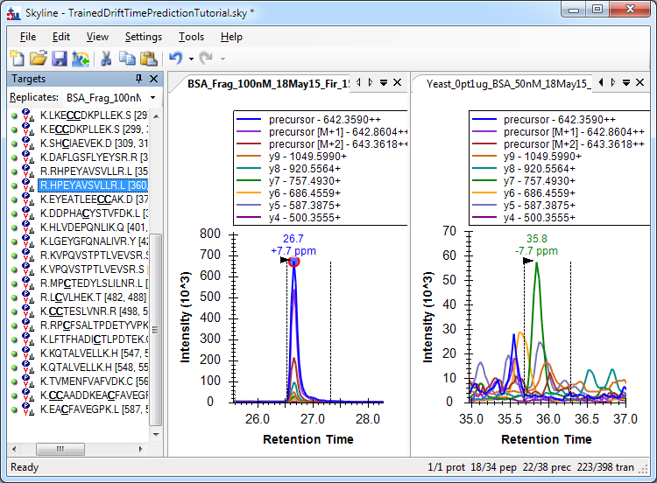

The panel on the left is from the BSA in water sample. On the right is the mixture sample. This is a plausible peak, but looking at the retention times we can see that it is probably not the correct peak. This is an ideal situation for using Ion Mobility Separation to simplify the signal for the analyte of interest.

Both data sets were acquired on the same IMS-capable mass spectrometer, so our next step is to analyze the simple BSA-only replicate to find peaks in the drift time dimension. With that information in hand, we can re-import the complex mixture, filtering out data that does not fall within a reasonable drift time window for each peptide.

First, we’ll unload the mixture replicate since we don’t want it as part of the training set. Use File | Edit | Manage Results to remove the mixture replicate “"Yeast_0pt1ug_BSA_50nM_18May15_Fir_15-04-01”.

Then, using the Settings | Peptide Settings… menu item, bring up the Peptide Settings dialog and select the Prediction tab.

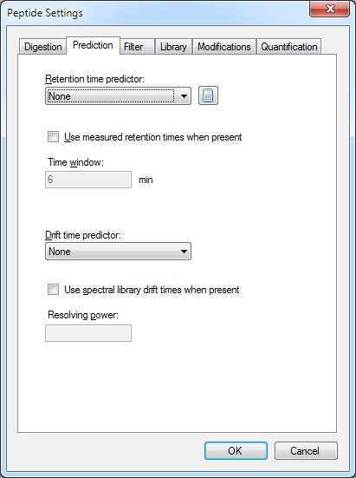

We are going to create a drift time predictor by examining the loaded replicate, looking for intensity peaks in the drift time dimension. Select “<Add…>” from the “Drift time predictor” pulldown to see this dialog:

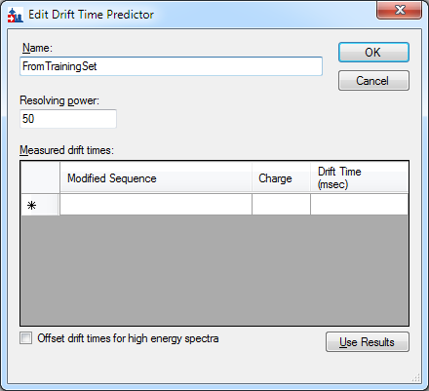

Set the name to something like “FromTrainingSet” and the Resolving power to 50, and click on the Use Results button. Skyline examines the loaded replicate and populates the predictor:

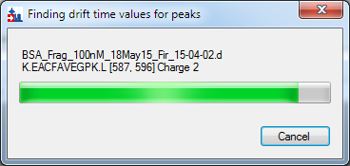

with this result.

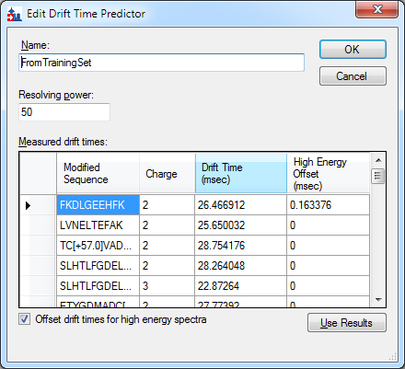

Note that Skyline found some differences between drift time peaks in MS1 and MS2 data – this is the “High Energy Offset” column. In some IMS hardware, the extra energy from the secondary collision cell causes the ions to enter the drift separator at somewhat different velocities than the parent ion, this value can be used to compensate for that.

Click the OK button, then click OK on the Peptide Settings dialog.

Now let’s use our new drift time predictor to reload the mixture replicate, and see the effect that IMS filtering has on peak interference. Use “File|Import Results” to load the "Yeast_0pt1ug_BSA_50nM_18May15_Fir_15-04-01.d" file. This time, Skyline will use the drift time predictor to ignore signal which does not match the expected drift time for each peptide.

Compare the signal with IMS filtering:

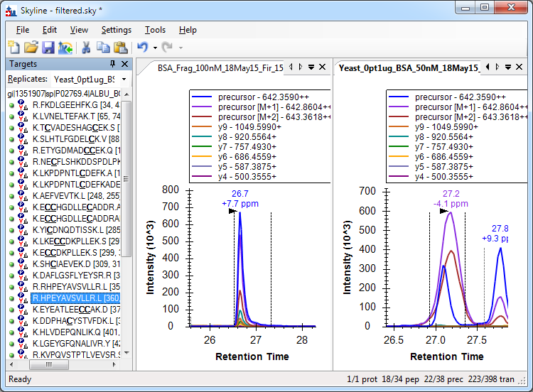

And without IMS filtering:



Without IMS filtering, Skyline chose the peak it did based on the strength of the y-ion matches, but by ignoring signal that does not match the known drift time peaks Skyline was able to identify the correct peak.

In future runs, the simple BSA-only replicate is no longer needed now that we have the drift time predictor.

# Conclusion

In this tutorial, you have learned how to create a drift time predictor by training it on a simple analyte mixture. You then used this drift time predictor to load a complex sample and use Ion Mobility Separation to remove peak interference for superior peak picking performance.